**Why Is Attic Ventilation Important in the Winter?**

Proper attic ventilation is important to the protection of your home and your comfort throughout the cold months. Attic ventilation in winter protects your roof structures from damaging moisture. Improve your attic ventilation to keep your home in good condition and maintain good indoor air quality this winter.

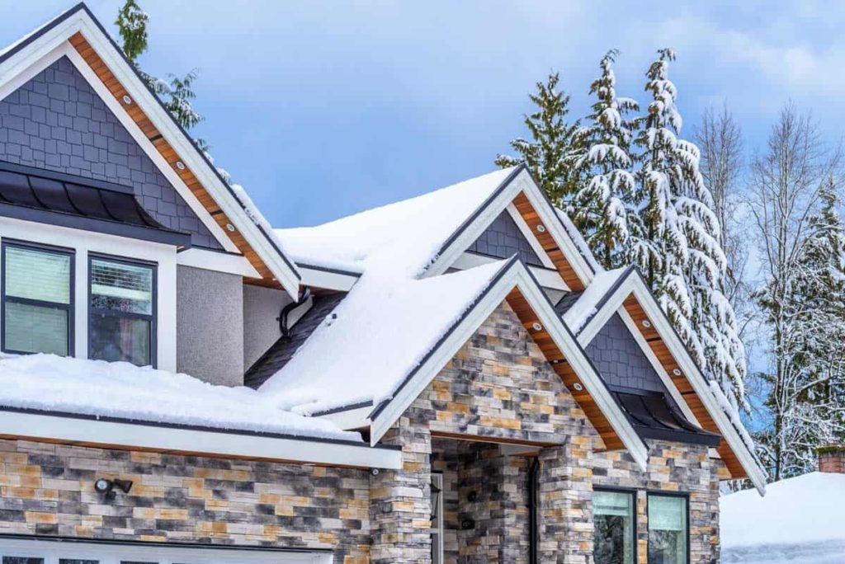

**Why Is Attic Ventilation Important?**

[Proper attic ventilation](https://www.hvac.com/videos/why-is-ventilation-important/) protects against many troublesome home problems, making your house more comfortable indoors. It protects your roof against damaging moisture problems, including:

Moisture variations that can warp roof decking

Mold growth

Frost

Wood rot

Popped shingles

Ice dams

In the winter, heat in your home rises – to the attic. With it comes moisture. When attics are not well ventilated, moisture collects in this area of the home. This moisture can seep into the structure of your home, affecting roofing materials as well as framing and contents of your attic.

Adequate attic ventilation allows cool, dry air from outside to come into the attic, while warm, moist air inside the attic can escape. Good attic [ventilation](https://www.hvac.com/blog/home-ventilation-tips-5-signs-need-dehumidifier/) helps keep temperatures even, preventing hot and cold spots that cause damaging ice dams where water can back up and freeze beneath your shingles.

Proper attic ventilation in winter prevents mold and mildew growth, safeguarding your family against these harmful contaminants. Eliminating moisture problems through attic ventilation works to improve indoor air quality. It also prevents the warm, damp, and dark environment that pests love, keeping rodents and insects from nesting in your attic.

**Attic Ventilation Solutions**

For good attic insulation, one square foot of ventilation is recommended per every 300 cubic feet of space within the attic. A [1:1 ratio](https://cleancrawls.com/the-importance-of-proper-attic-ventilation/" \t "/Users/macbookpro/Documents\\x/_blank) of intake and exhaust vents is needed to ensure proper airflow through your attic. Roof vents allow for natural attic ventilation, but mechanical solutions are also available.

**Intake Vents**

Intake vents allow air to move into the attic. There are three main types of intake vents for attic ventilation in winter:

Gable vents: Gable vents are installed at the roof peak’s highest point in the gable. They can be painted and a number of styles are available to blend with your home’s exteriors. Depending on wind direction, gable vents can serve both intake and exhaust purposes.

Under-eave vents: An under-eave vent is a continuous, perforated vent that is installed under the home’s eave. These vents can be easily covered by attic insulation, so make sure insulation is not installed over the vent.

Rafter vents: Rafter vents work with under-eave vents to provide clear airways to the under-eave vent. They are installed along the attic’s rafters, located at the point where ceiling and attic floor meet.

**Exhaust Vents**

Exhaust vents allow warm, moist air to move out of the attic space. Types of exhaust vents include:

Ridge vents: These vents run along the roof’s ridge. They are easily disguised by shingles, integrating nicely with the roof line.

Turbine vents: Turbine vents have a distinctive look, and contain a small fan that turns with the breeze. This sucks warm, moist air out of your attic, expelling it outdoors. Turbine vents are installed on or close to the roof’s ridge.

**Attic Ventilation Fans**

[Attic ventilation fans](https://www.energystar.gov/index.cfm?c=diy.diy_attic_ventilation" \t "/Users/macbookpro/Documents\\x/_blank) offer mechanical ventilation, using a fan to draw in cool, outside air and force out warm, moist air. Air is drawn in through the attic fan and air is expelled through the roof vent system to keep your attic cooler and drier, preventing ice and moisture issues throughout the winter. Attic fans do require electricity to operate, which makes this attic ventilation solution more costly to operate than relying on natural attic ventilation through vents.

**Attic Ventilation To-Do List**

In addition to the attic ventilation solutions above, there are more steps you can take to prevent moisture issues in your attic and help maintain proper attic ventilation throughout the winter:

Seal penetrations in the attic to stop free air flow. Seal nail penetrations and around electrical, HVAC, and chimney penetrations.

If your roof vents have been damaged, replace them as well as crushed ridge vents to aid in proper ventilation.

Do not cover your attic vents for the winter. Doing so in attempts to keep cold air out disrupts attic ventilation, leading to moisture issues.

Make sure the space between the top of insulation and the roof deck’s underside is clear at the eaves. This allows air to move through the rafter space for good ventilation.

From:<https://www.hvac.com/blog/why-is-attic-ventilation-important-in-the-winter/>